Session 7

1. Create employee data in a data.js file and include following fields (name, age, DOB, salary, designation, image, department).

Display name, image, designation in UI. Whenever user hover over any name, display complete employee data in alert/modal.

Code:

Data.js

App.js

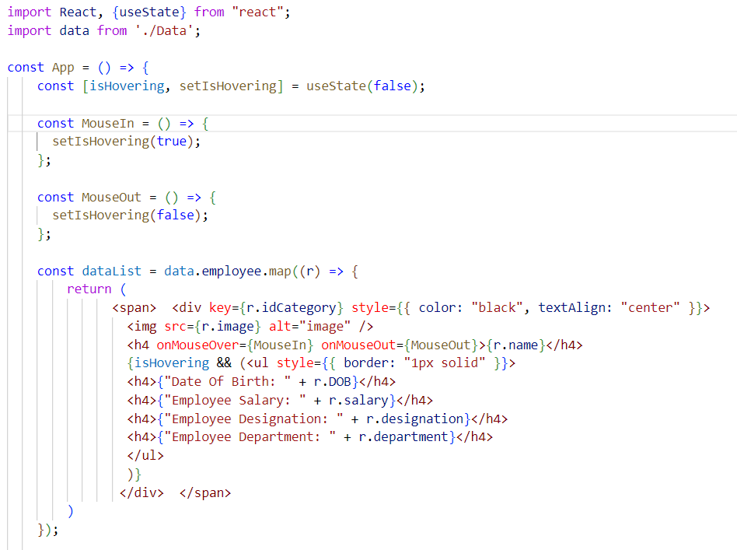

Result:

Before Hover.

After Hover:



2. Create an array of grocery data, send data from 1 component to another and display it

Code:

groceryData.js

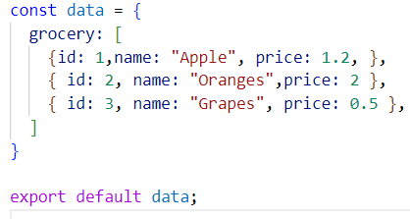

AppGrocery.js

Result:

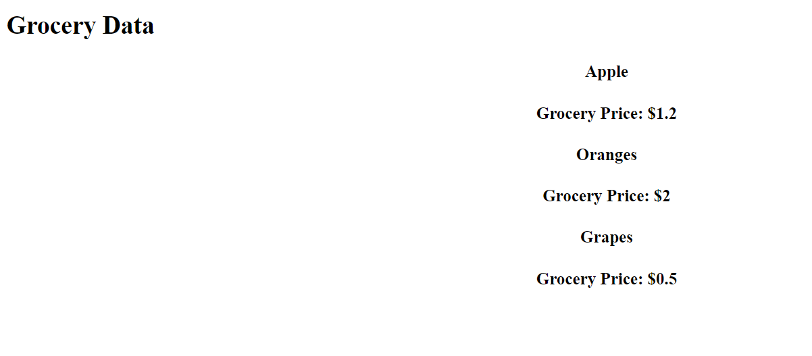

3. Create an object pass data from 1 class based to another class based data and display it (Hint: this.props).

Code:

groceryData.js



ItemsList.js

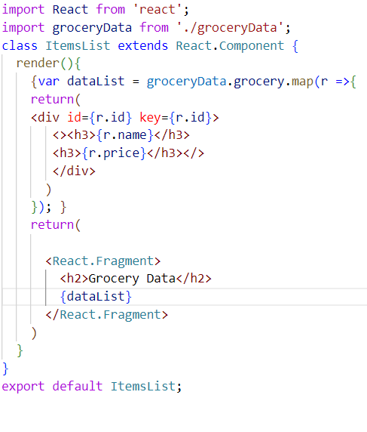

Result:

